Amazon Machine Learning is a managed service for building ML models and generating predictions, enabling the development of robust, scalable smart applications. Amazon Machine Learning enables you to use powerful machine learning technology without requiring an extensive background in machine learning algorithms and techniques.

The process of building ML models with Amazon Machine Learning consists of three operations: data analysis, model training, and evaluation. The data analysis step computes and visualizes your data’s distribution, and suggests transformations that optimize the model training process. The model training step finds and stores the predictive patterns within the transformed data. In the final step, the model is evaluated for accuracy.

In this lab, we build a Machine Learning model that will predict whether the customer will like the restaurant or not. The data source use here for the machine learning model is based on customer reviews and is supervised data set. The features sets passed to the Machine Learning model is the age, gender and budget preference of the customer as well as the price and cuisine type of the restaurants. The values returned will be one of the following:

1. Excellent
2. Very good
3. Satisfactory
4. Dislike

In this lab, we downloaded the data set used to train the model, examine and process the features set, then train and evaluated the model and finally made predictions based on the model build.

To begin, the data set is upload into S3 bucket. We need to create a S3 bucket where the data set will be uploaded. Once the data set is uploaded in the Amazon S3 bucket, create a new Datasource and ML Model in Amazon Machine Learning service. Link your data set uploaded to S3 bucket earlier and validate it. It is a Supervised Learning data set, select the target variable. Review the Machine Learning Model and create it.

Once done, we create a ML model based on the datasource. One can create multiple models from single data source so that we can evaluate which model performs best. In the Amazon Machine Learning, we create a ML Model.

Once the status has been changed to completed, we will observe that the data set has been split in 70:30 of train and test data set. ML model used here was multiclass classification where one value is predicted from set of possible values. To visualize the accuracy, refer to the confusion matrix where True/True, True/False, False/True and False/False percentage are shown.

There are two ways to generate predictions – Batch mode and Real-Time Mode. In Real-Time Mode, you enter sets of attributes/features values from where you want the predicted values. Batch Mode is asynchronous. To define a data source which you will upload to get the predicted values of that data source.

Thus, we have completed the entire workflow of Machine Learning.

Screenshots:



Upload Training Data

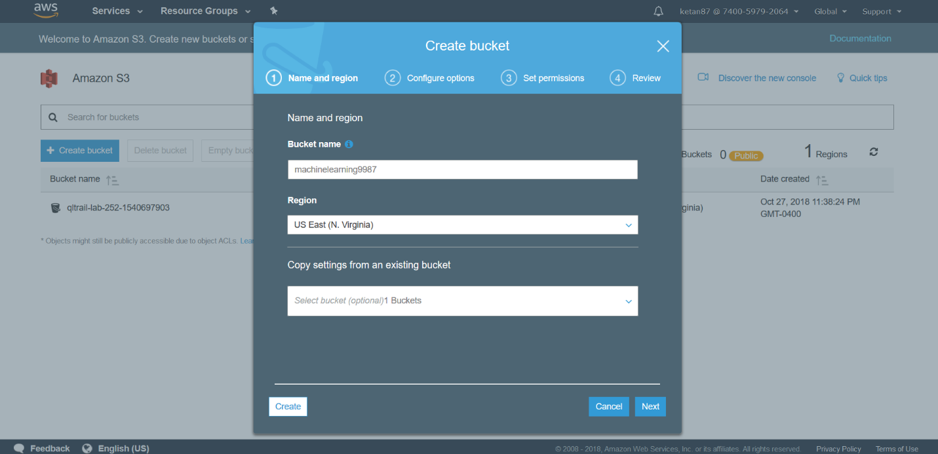

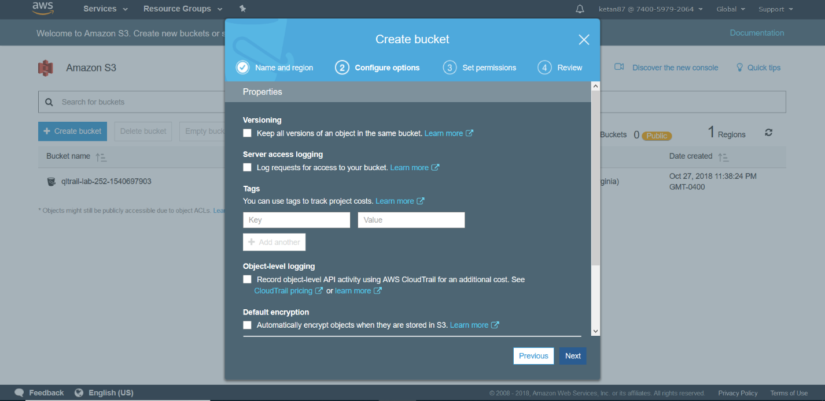

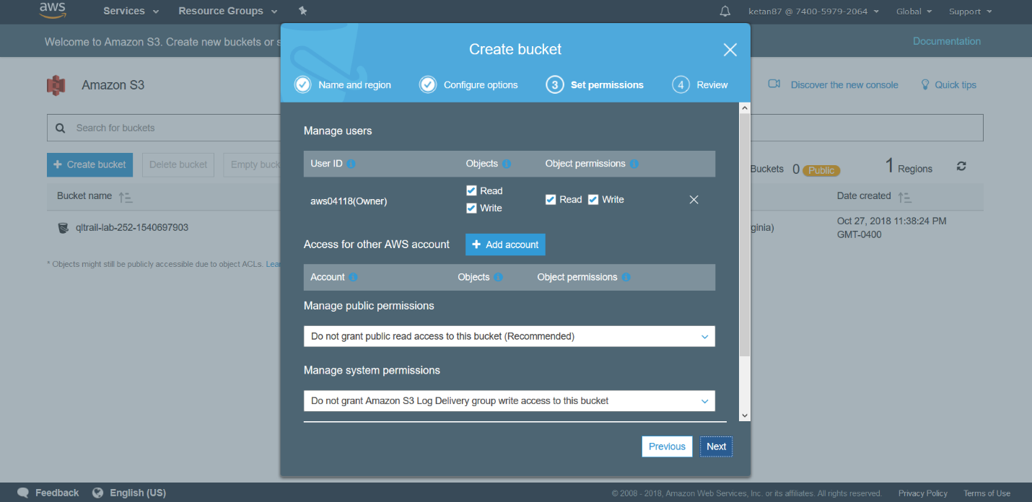

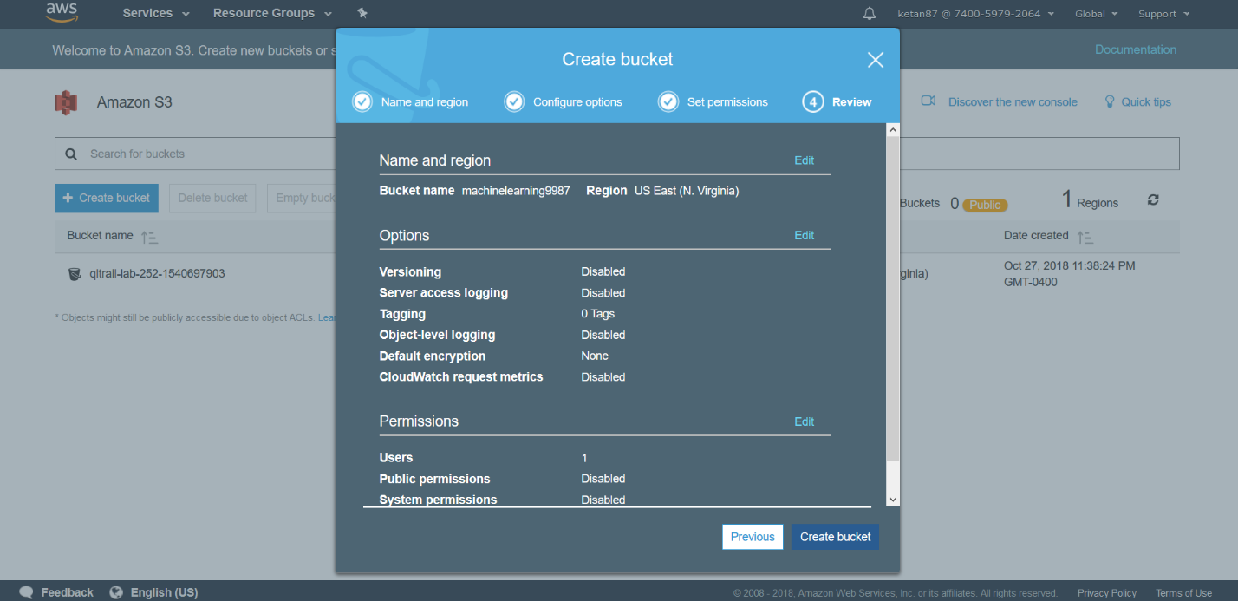

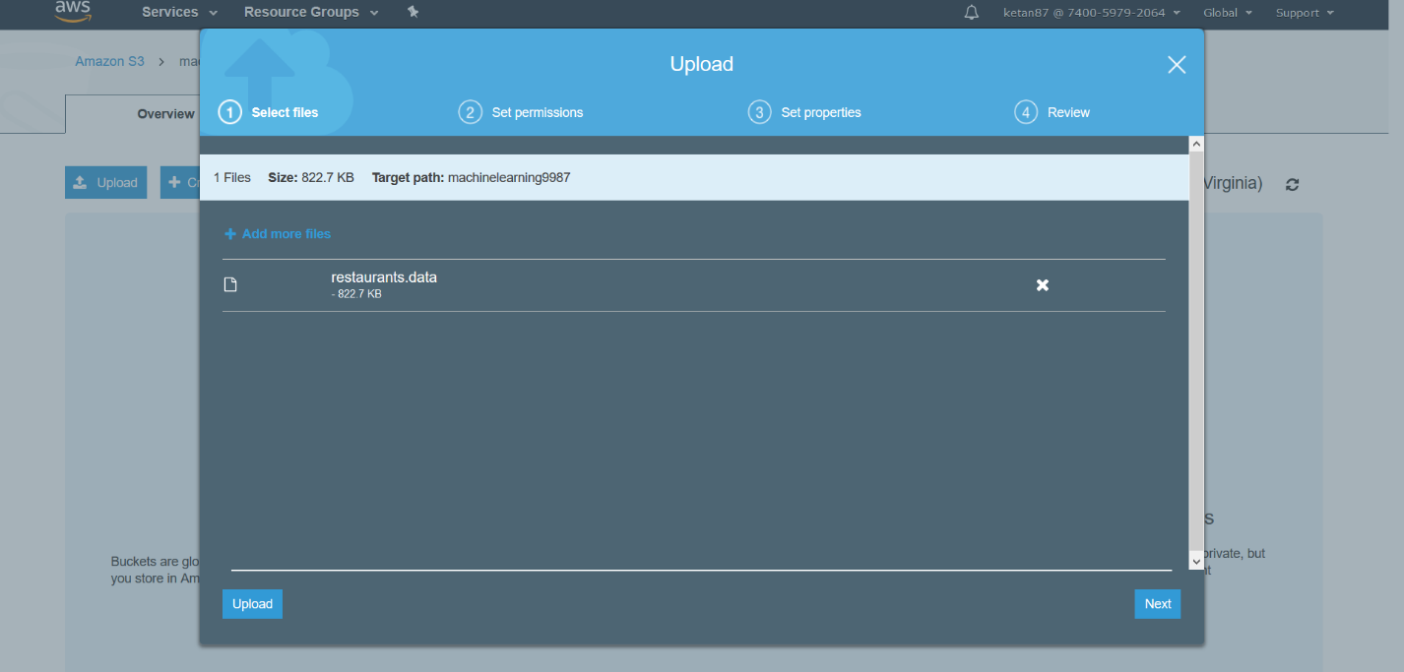

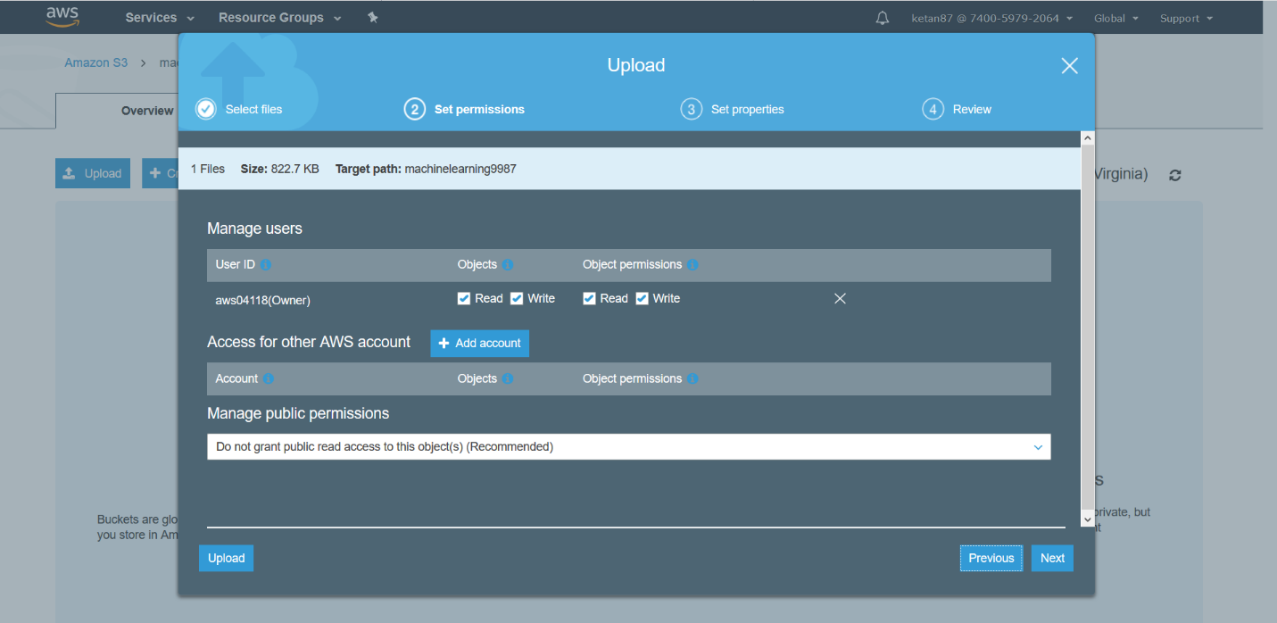

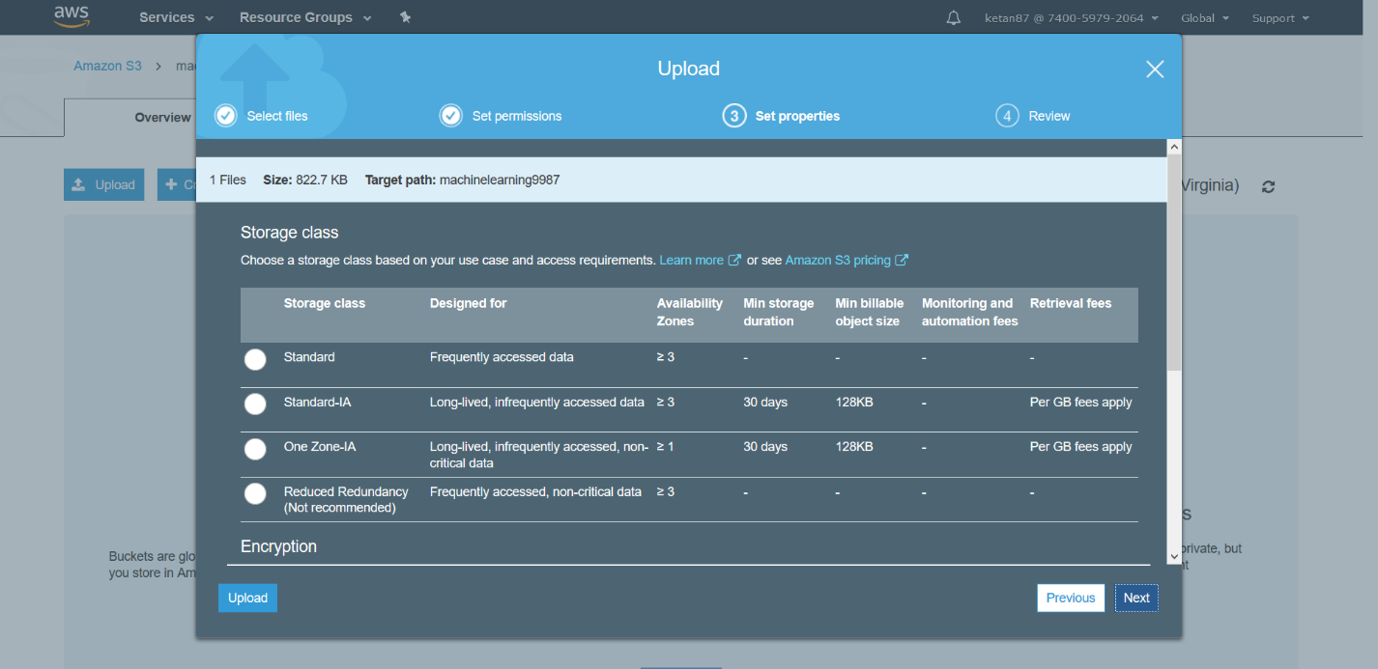

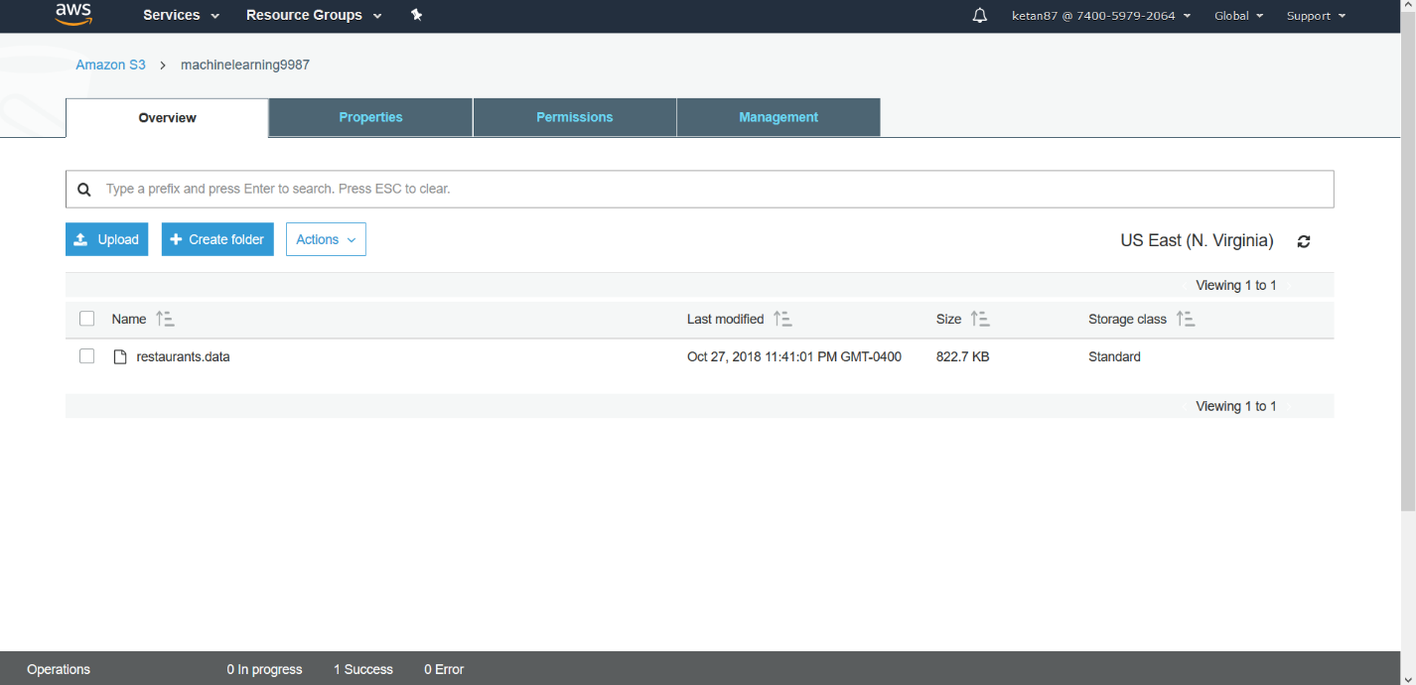

Create a Datasource



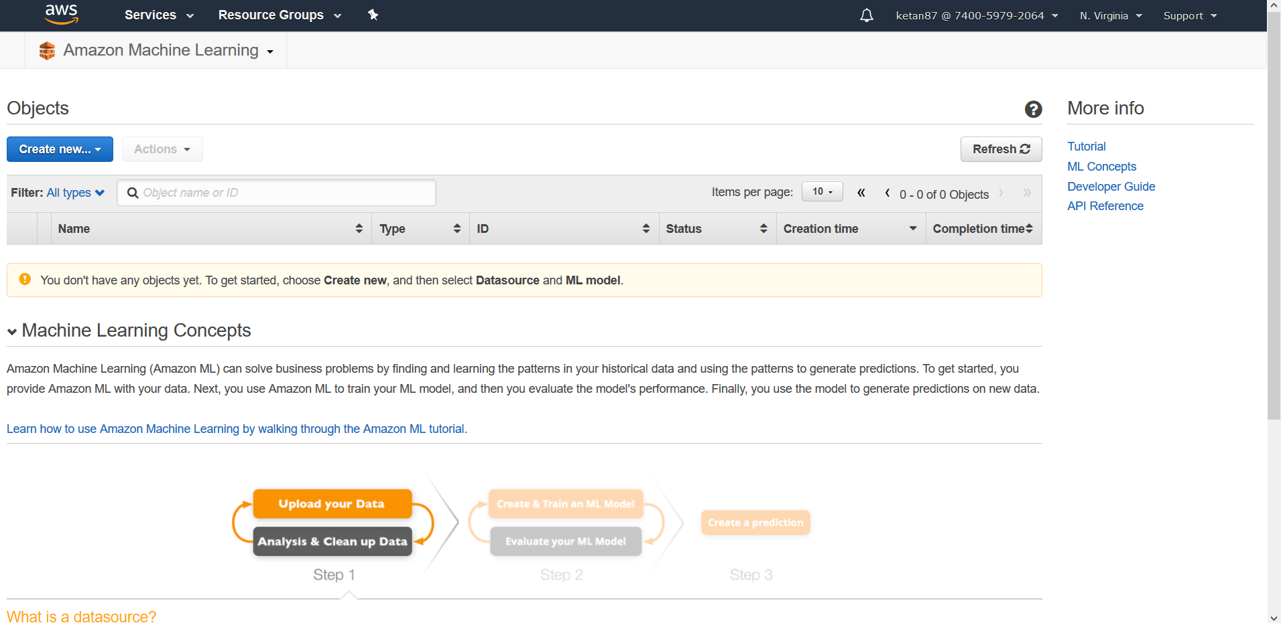

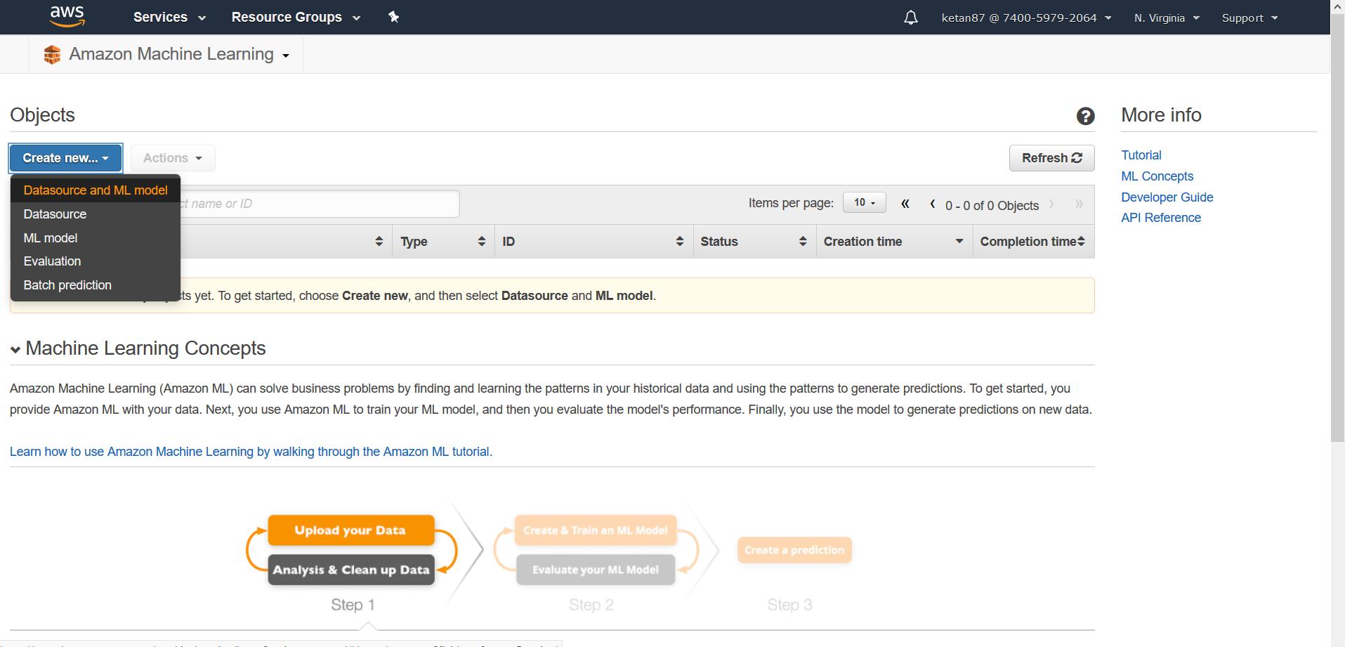

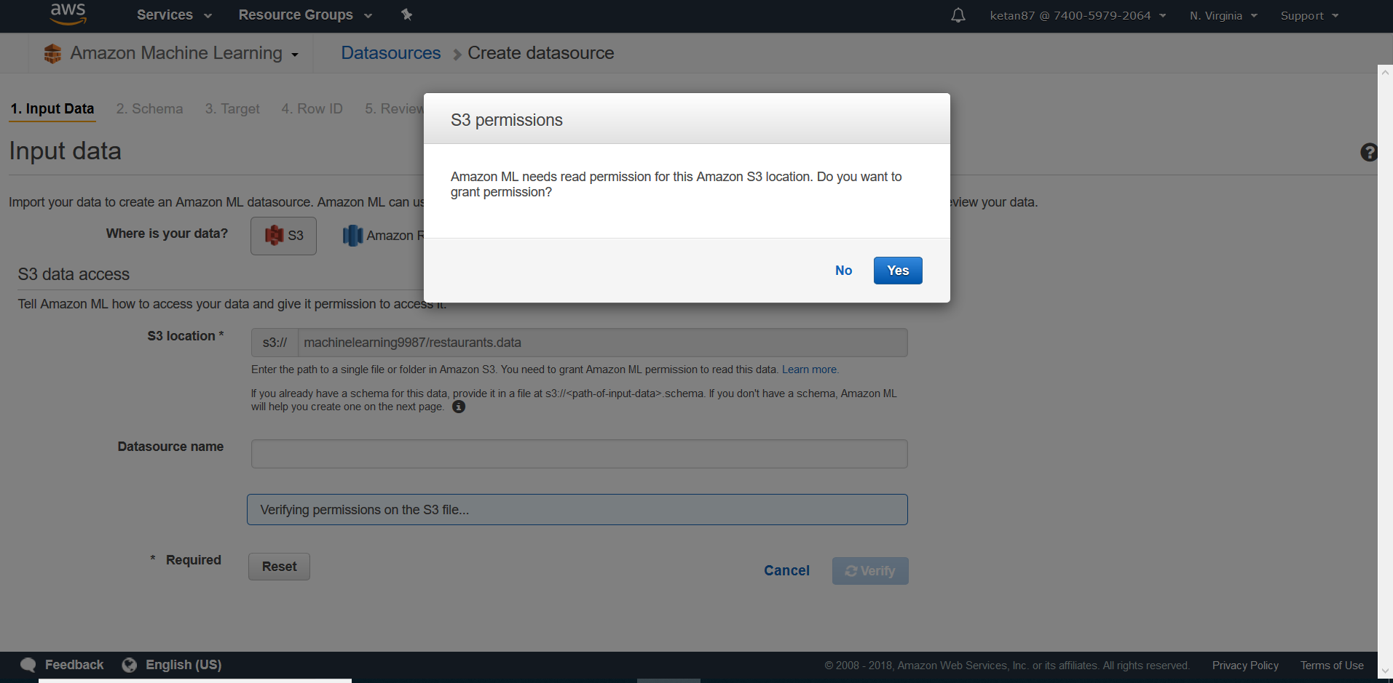

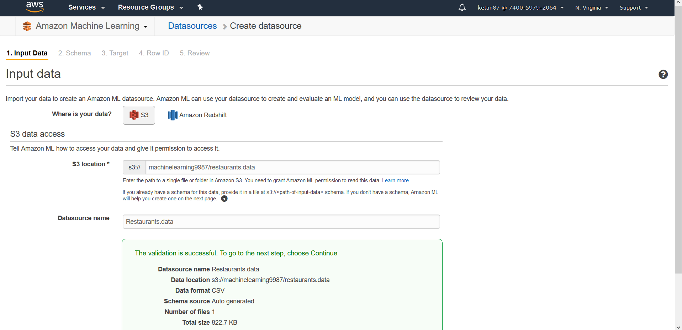

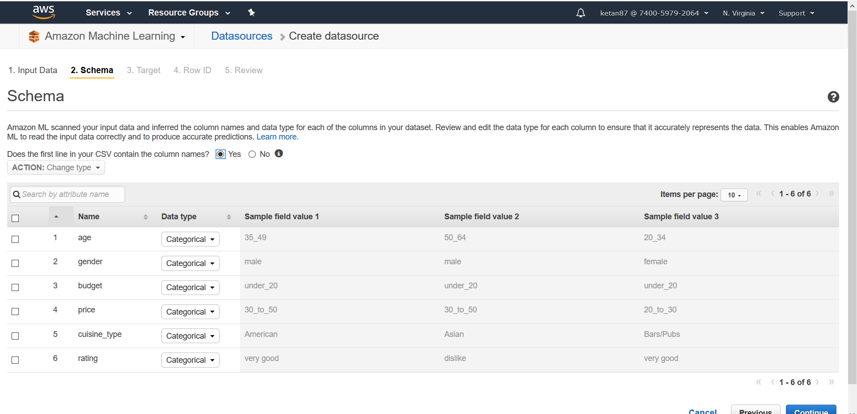

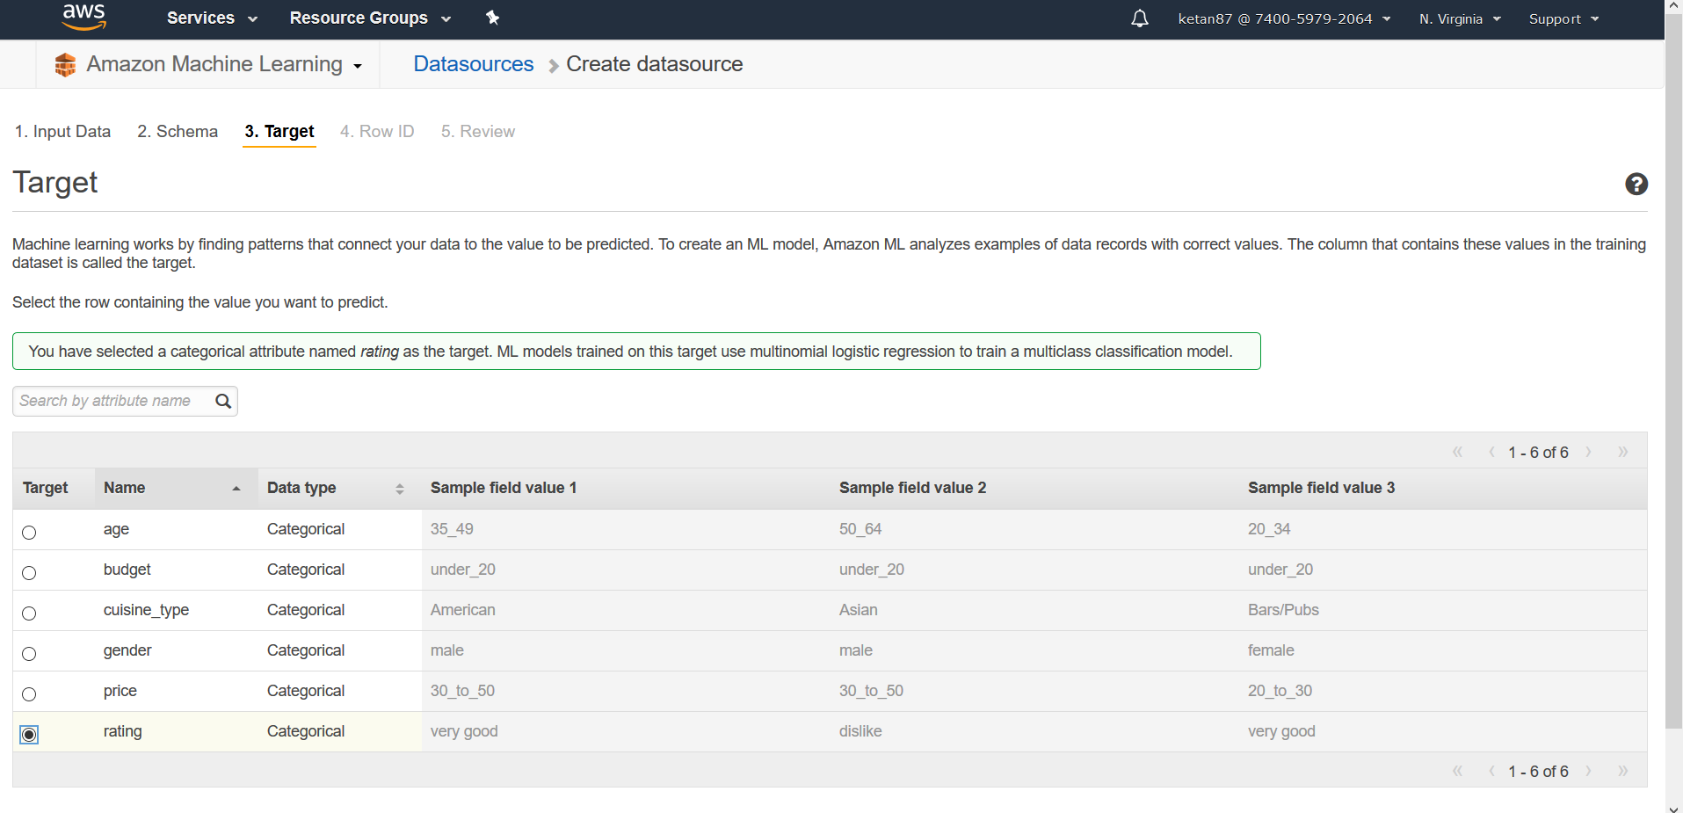

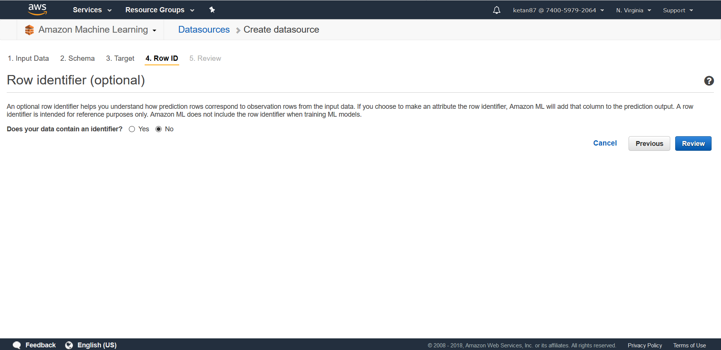

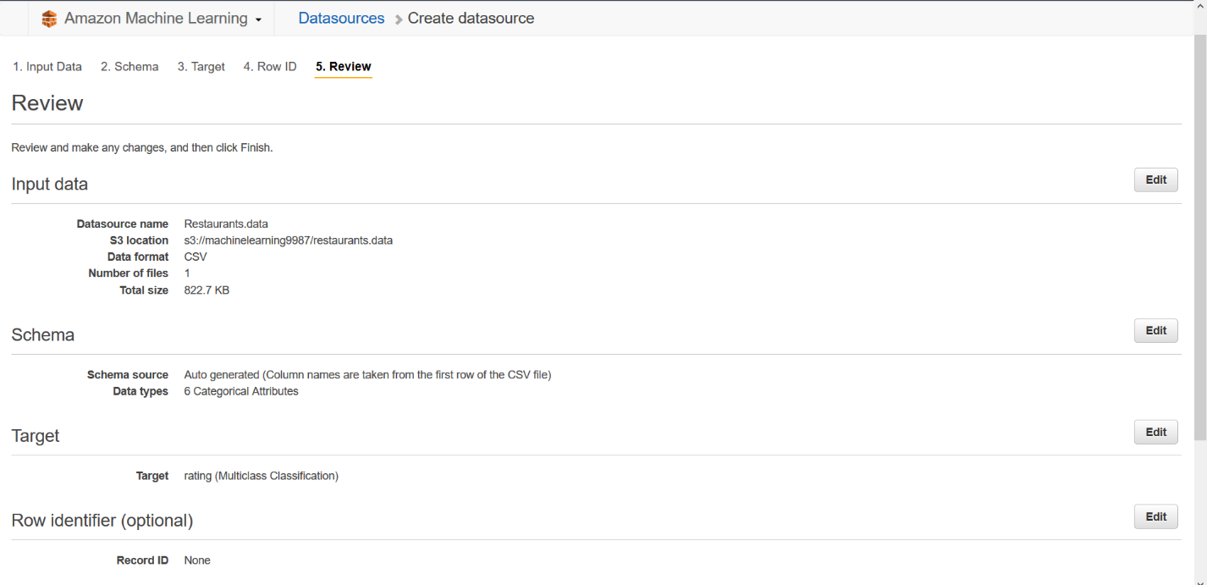

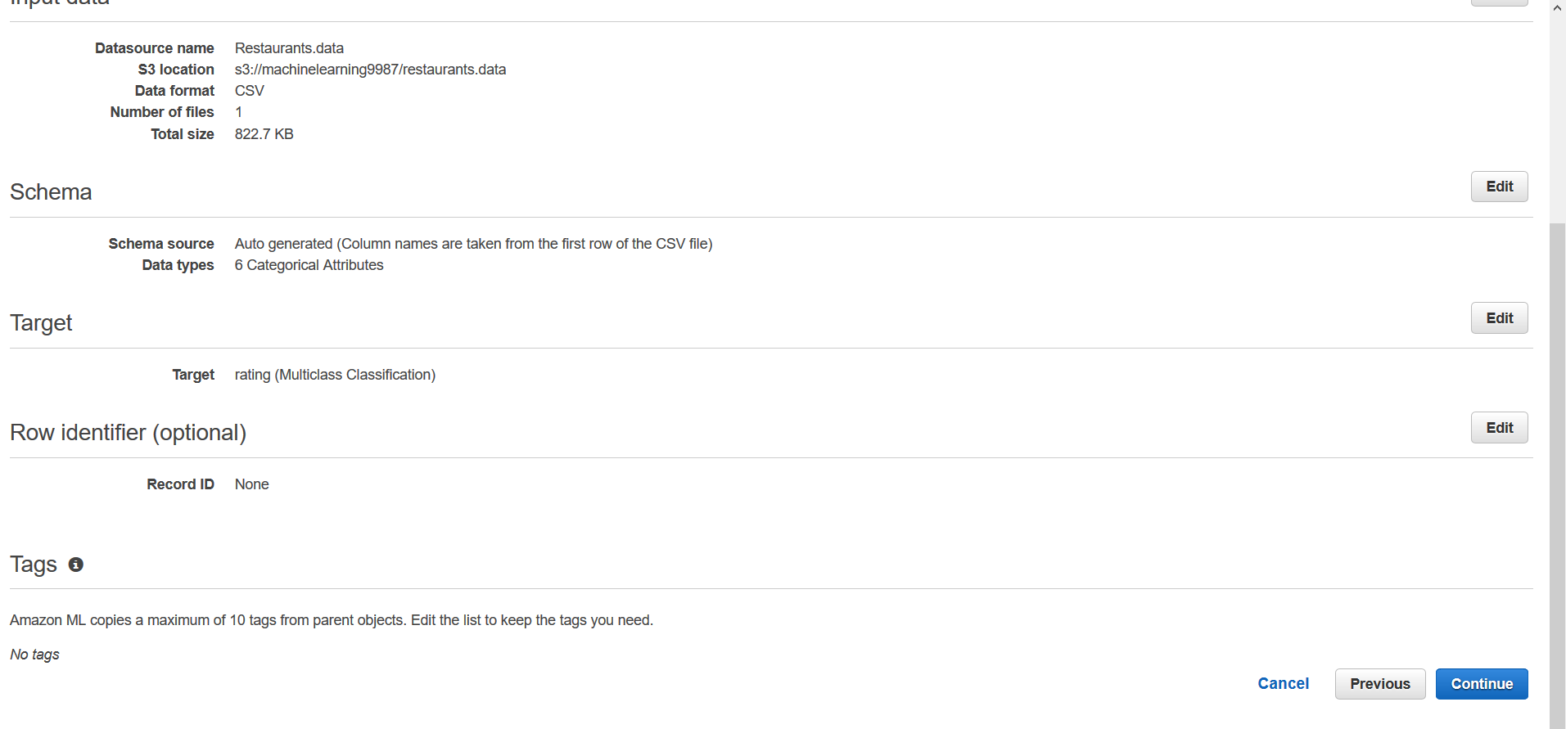

Create an ML Model from the Datasource

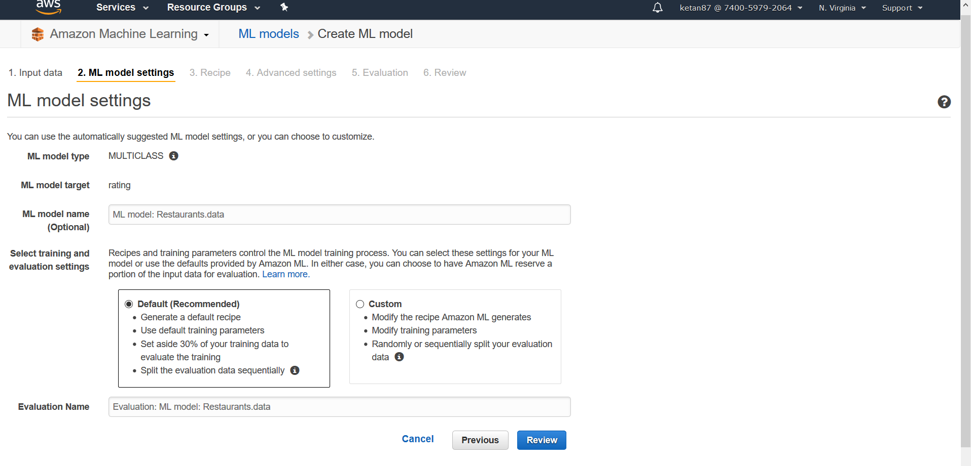

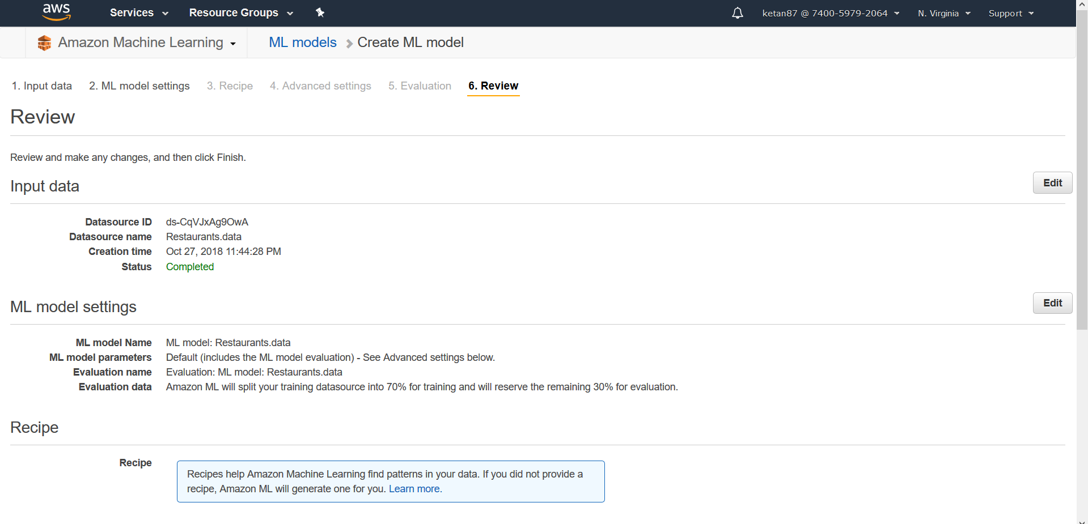

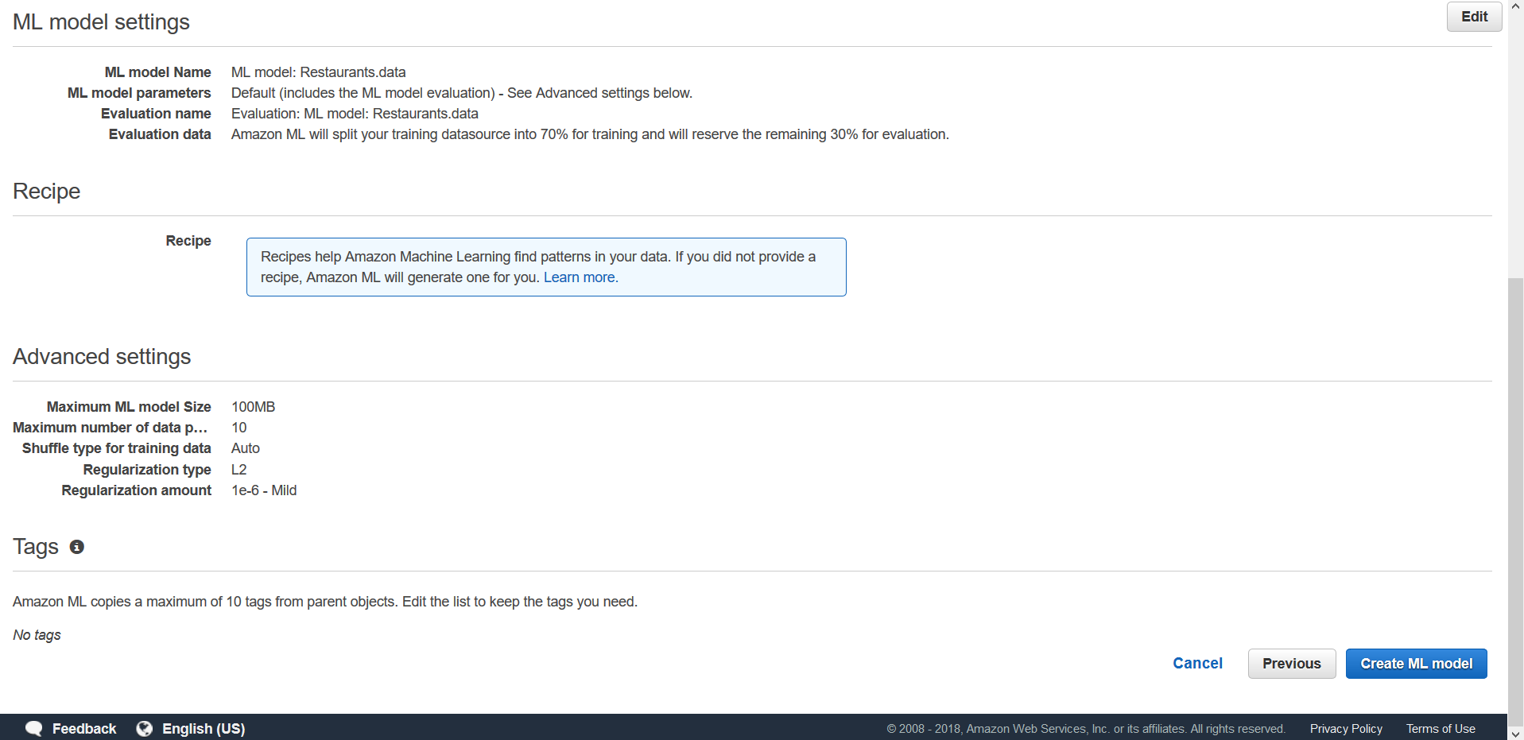

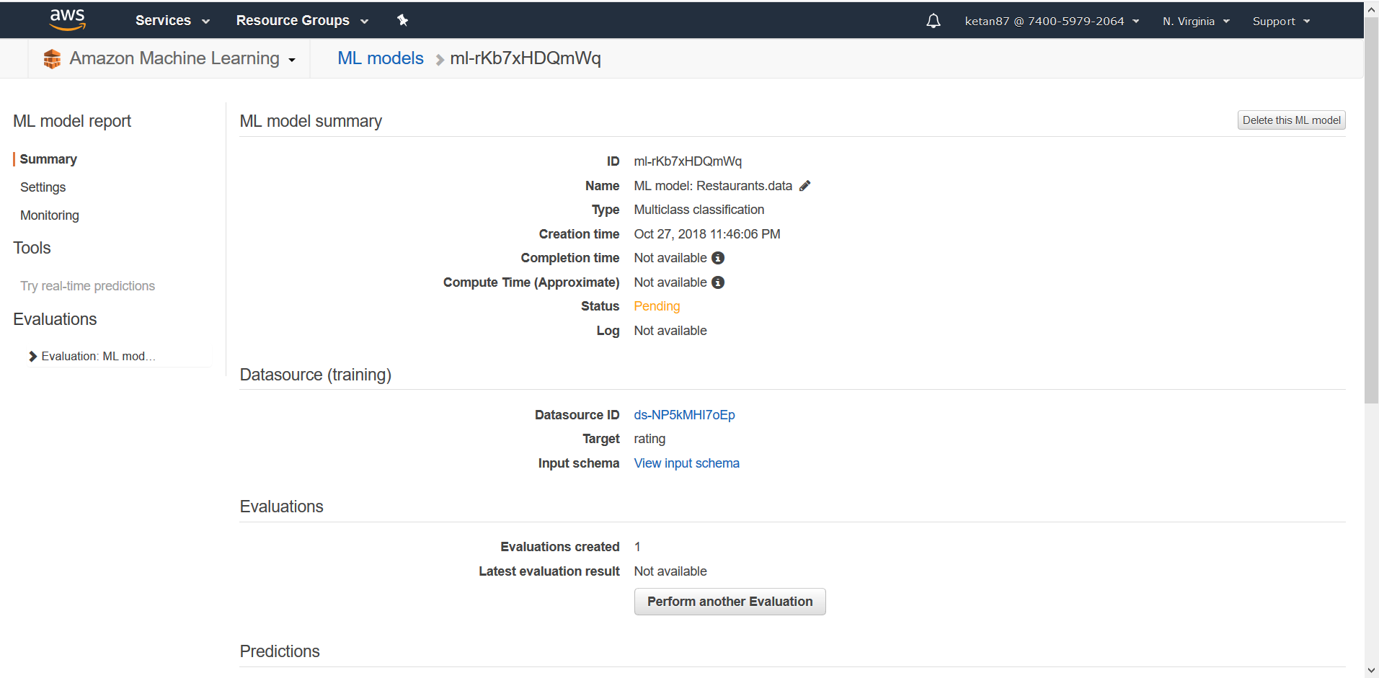

Evaluate an ML Model

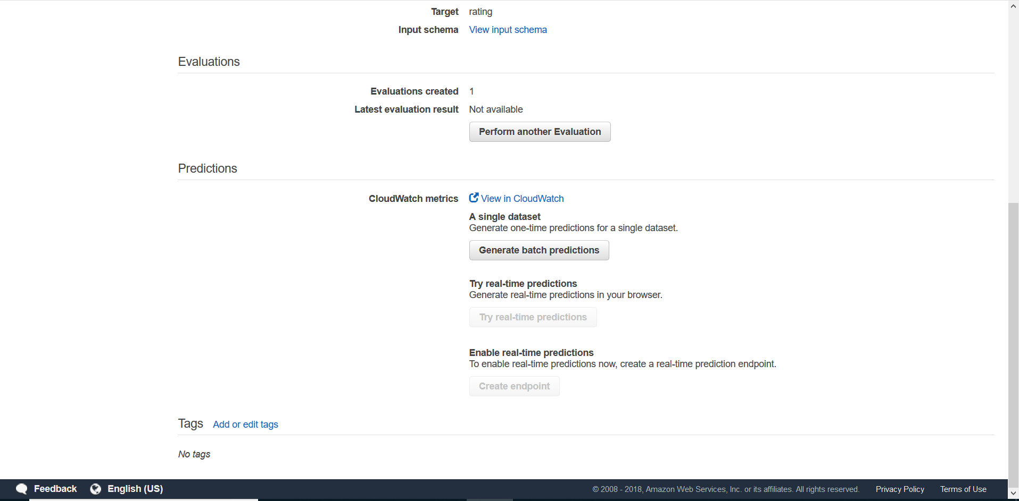

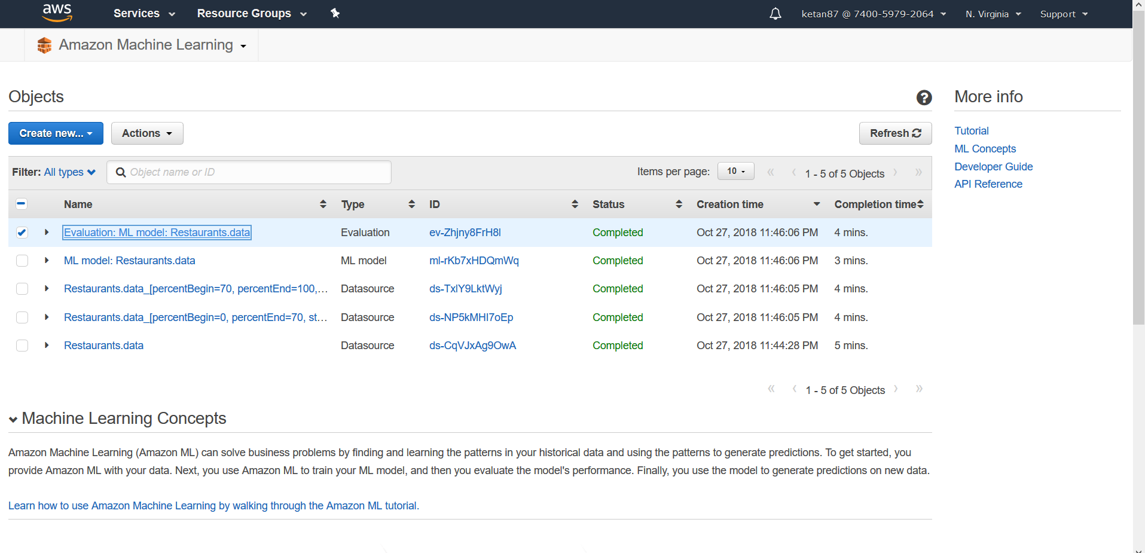

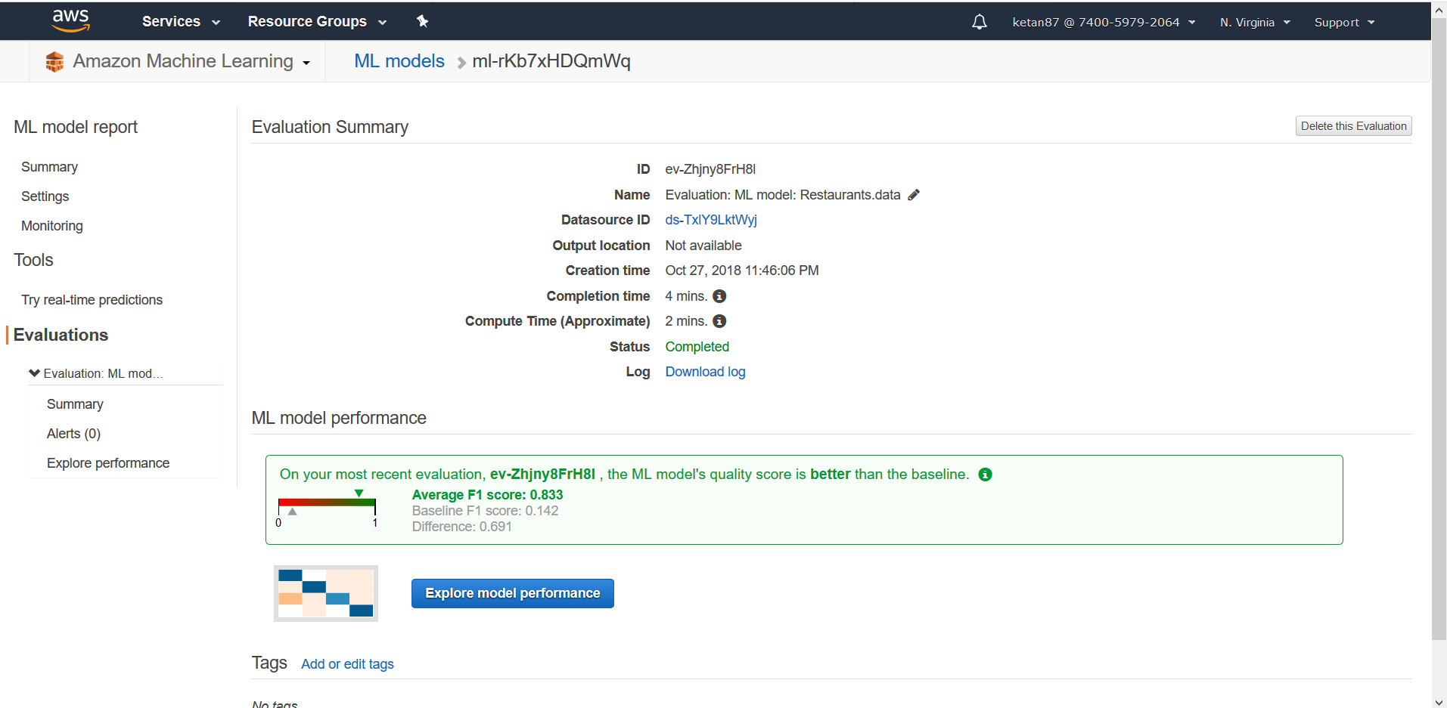

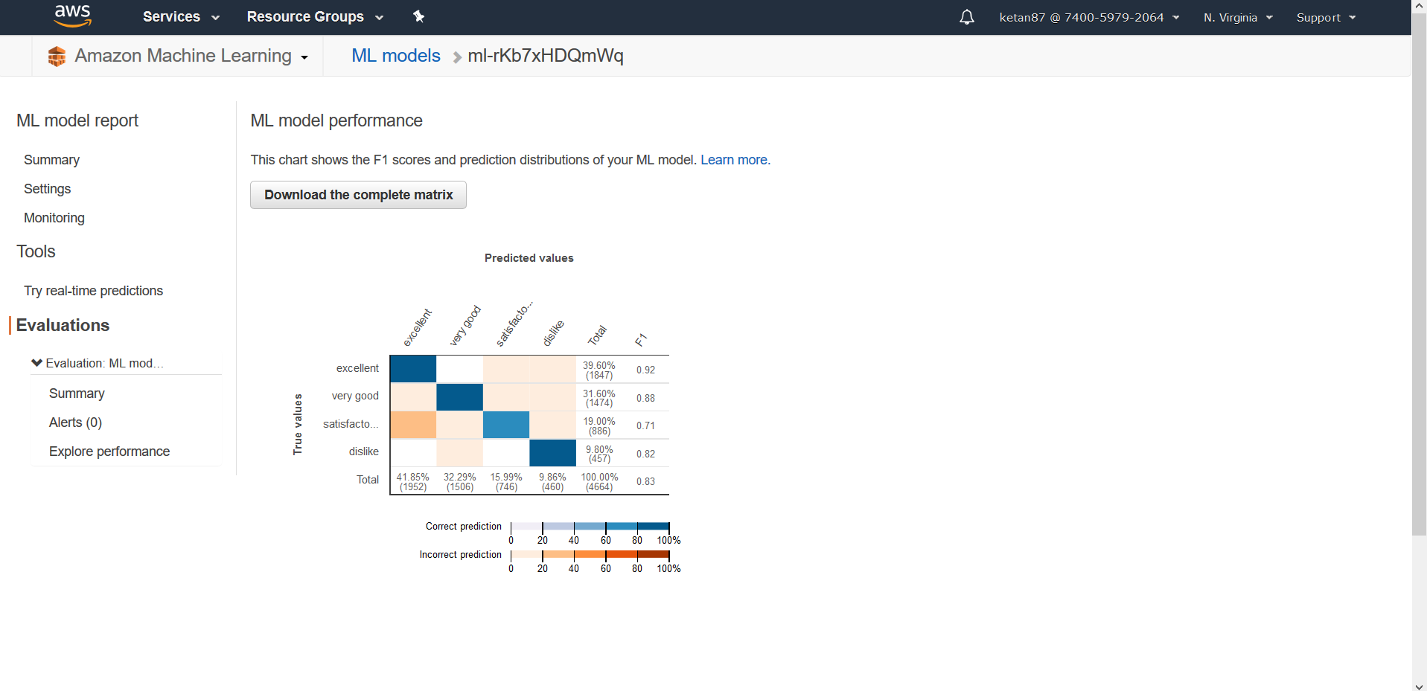

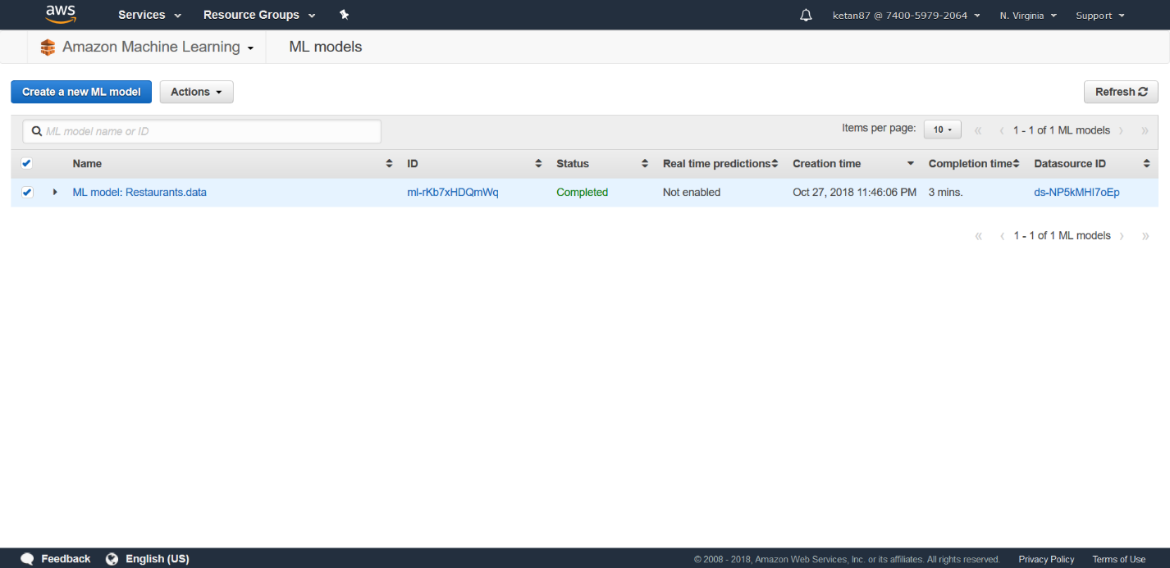

Generate Predictions from your Model

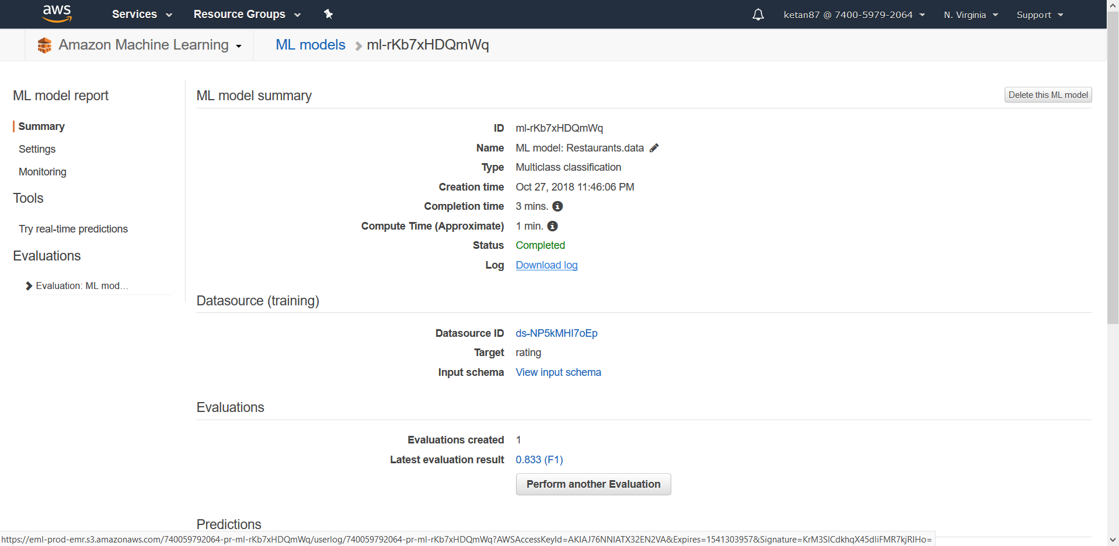

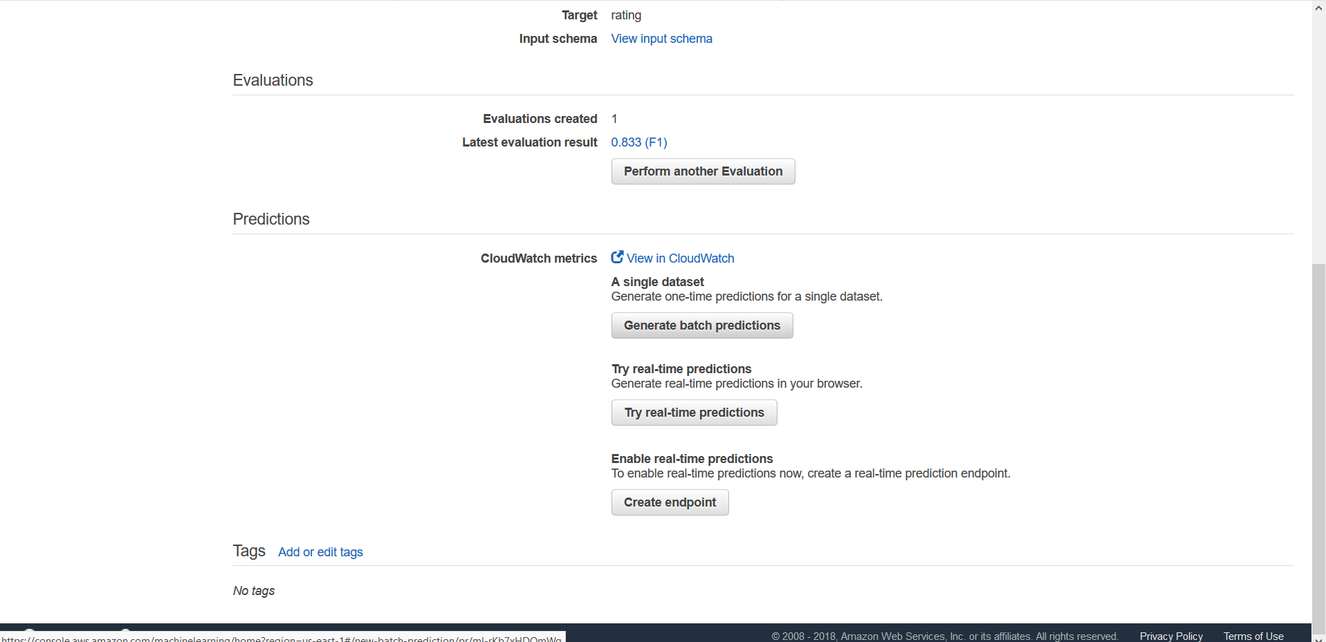

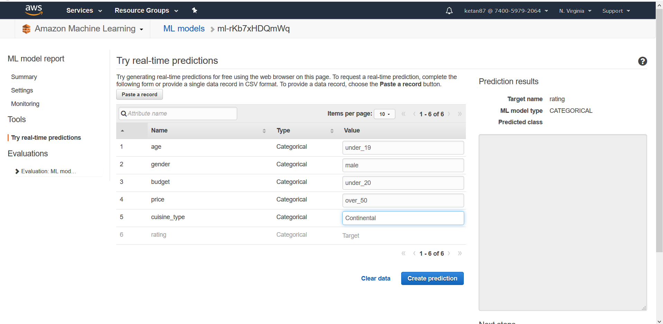

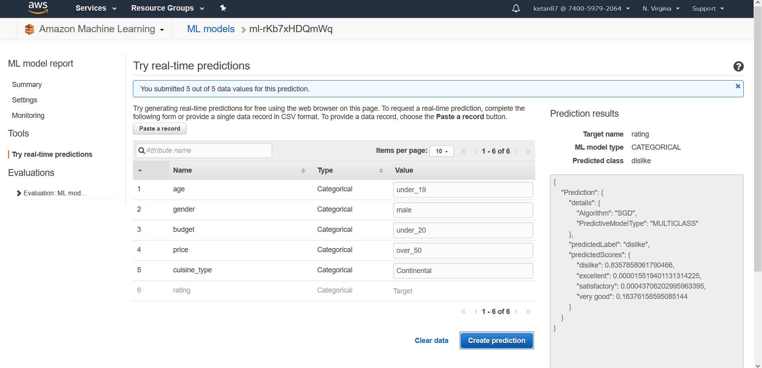

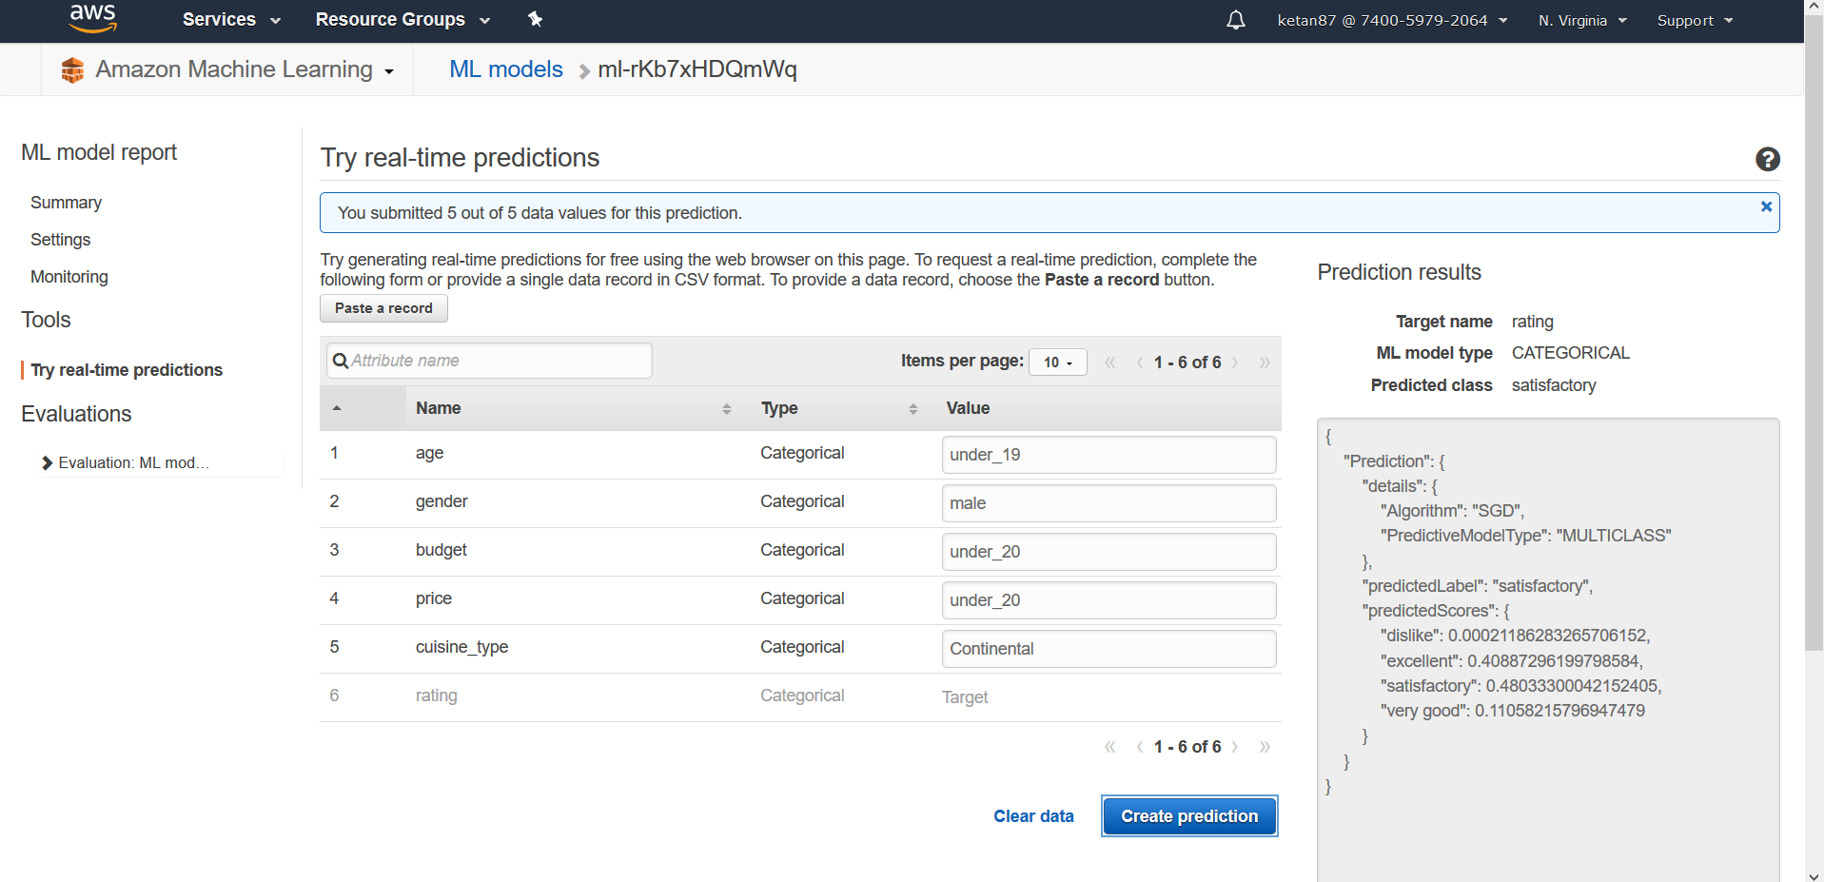

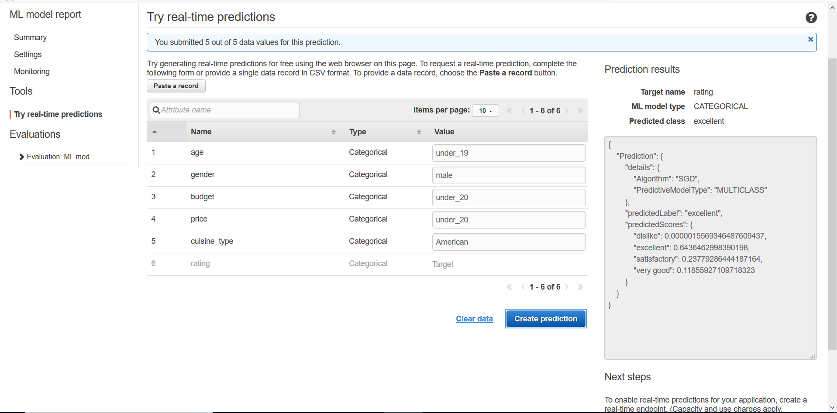

Total Time: 1 Hour 20 minutes